Renal1: Acute Renal Failure
HISTORY
31 year old woman who was previously in good health presents to the clinic with a 4 day history of severe nausea and vomiting. She has been unable to keep down liquids secondary to profound nausea. She also reports general fatigue and weakness over the past week and a 2 day history of swelling in her lower legs, face and arms. She denies any fever or chills, but does report feeling feverish approximately 2 weeks ago in the setting of a severe sore throat with both symptoms resolving after a few days.

She has no cough but does describe mild shortness of breath with exertion over the past week. No abdominal pain, diarrhea or constipation. She has no dysuria() but does note that urine has been small in volume and brownish in colour. She reports no new medications, no changes in diet, no one sick at home, she does work in an elementary school and often gets sick.

Past Medical History : depression Allergy: No known drug allergies

Social History: No smoking, alcohol intake, no drugs.

Temp 36.2C BP 155/95 HR 85 RR 16 O2 sat 94% RA

PHYSICAL EXAMINATION

Ill appearing young woman with swollen face. Abdomen is soft, +BS, mildly and diffusely tender to palpation, non distended
Extremities: Pitting edema in hands and legs, no rashes, no joint abnormalities

Renal2: Gout
HISTORY
CC/ID: 52-year-old man with a painful. swollen, hot right knee. Mr… was awakened from sleep last night by exquisite pain in his right knee, which had become swollen and warm. He had felt well during the day preceding the onset of pain. and had attended a crab-fest that afternoon. He denies trauma to the joint. penetrating injuries, injections, or extramarital sexual contact. He lives in the city and does not enjoy hiking or camping, although he likes to fish.
He cannot recall any tick exposures. He reports subjective fevers and sweats, but hasn't taken his temperature; the ROS is otherwise negative. Although no other joints currently hurt, he recalls an intensely painful left big toe several years ago that got better with "aspirin. "
Past Medical History: Hypertension; ; hernia repair. Meds:. HCTZ. 25 mg All: NKDA
Family History/Social History: Parents both deceased; father had "arthritis." Married, with two adult children.

PHYSICAL EXAMINATION
VS: Temp 39C. BP 150/90. HR 100, RR 16. 02 sat RA

Gen: large man, lying on gurney, nontoxic but uncomfortable. HEENT: unremarkable. Neck: supple, no thyromegaly or adenopathy. Lungs: clear. Q': RRR. normal S,Sz, 216 HSM at apex.
Abdomen: soft. NT/ND, +BS. Ext: no track marks; right knee swollen, warm, tender to touch; no swelling or lymphangitis; 2+ peripheral pulses. Skin: no rashes. no necrotic-appearing lesions. Genitourinary system: no urethral discharge. Neuro: nonfocal.
LABORATORY

WBC 13; Hct. Plt Count normal; Cr 1.2; serum urate normal; INR 1.0.

Renal4: Nephrotic Syndrome
PHYSICAL EXAMINATION

Mr. …, 17 years old, student, normotensive, non-diabetic, non-smoker, hailing from …, presented with generalized swelling of the whole body for two months. Initially, he noticed swelling around the eyes and face, followed by arms, abdomen and then legs. He also complains of scanty micturition, but there is no history of burning, hematuria or pain.

For the past few months, he is experiencing weakness and loss of appetite. There is no history of sore throat, breathlessness, cough, chest pain, bowel abnormality or cold intolerance and jaundice. He did not give any history of skin rash, joint pain or oral ulcers, or weight loss. For this illness he took frusemide tablets and some antibiotics as prescribed by the local physician. There is no history of taking any herbal medicine and nephrotoxic drugs. There is no family history of such illness. Urine shows gross proteinuria.

PHYSICAL EXAMINATION
The patient is grossly edematous, the face is puffy with baggy eyelids. Pitting edema is present
Mildly anemic. No clubbing, jaundice, cyanosis, koilonychia, but leukonychia involving all the nails of fingers and toes is present. No lymphadenopathy or thyromegaly

Pulse—90/min regular in rhythms
BP—110/75 mm Hg.

Systemic Examination

Gastrointestinal system
Lips, gum, tongue, oral cavity—normal.

Abdomen
1. Inspection:
There is generalized distension of abdomen. Umbilicus is everted. Scrotum and penis are grossly swollen.
2. Palpation: No organomegaly. Kidneys are not ballotable. Fluid thrill—present. There is no tenderness over the renal angle. Genitalia—scrotum and penis are swollen
3. Percussion: Shifting dullness present. There is gross ascites as suggested by presence of shifting dullness and fluid thrill.
4. Auscultation: No abnormality.

Cardiovascular System
There is no abnormality.

Respiratory System
There is no abnormality.

Examination of the other systems reveals no abnormalities.

Bedside urine for protein +++, sugar nil.
Citation: Abdullah, A B M. Long Cases in Clinical Medicine. Jaypee Brothers, 2013.

Renal5: Renal Failure
HISTORY

An 85-year-old woman is investigated by her general practitioner (GP) for increasing tiredness
which has developed over the past 6 months. She has lost her appetite and feels constantly
nauseated. She has lost about 8 kg in weight over the past 6 months. For the last
4 weeks she has also complained of generalized itching and cramps. She has been hypertensive
for 20 years and has been on antihypertensive medication for that time. She has
had two cerebrovascular accidents which have limited her mobility. She is an African-
Caribbean, having emigrated to the UK in the 1960s. She lives alone but uses a ‘meals on
wheels’ service and goes to a day hospital twice a week. She has two daughters.

PHYSICAL EXAMINATION

Her conjunctivae are pale. Her pulse is 88/min regular, blood pressure 190/110 mmHg;
mild pitting oedema of her ankles is present. Otherwise, examination of her cardiovascular
and respiratory systems is normal. Neurological examination shows a left upper motor
neurone facial palsy with mild weakness and increased reflexes in the left arm and leg.
She is able to walk with a stick. Fundoscopy shows arteriovenous nipping and increased
tortuosity of the arteries.

LABORATORY
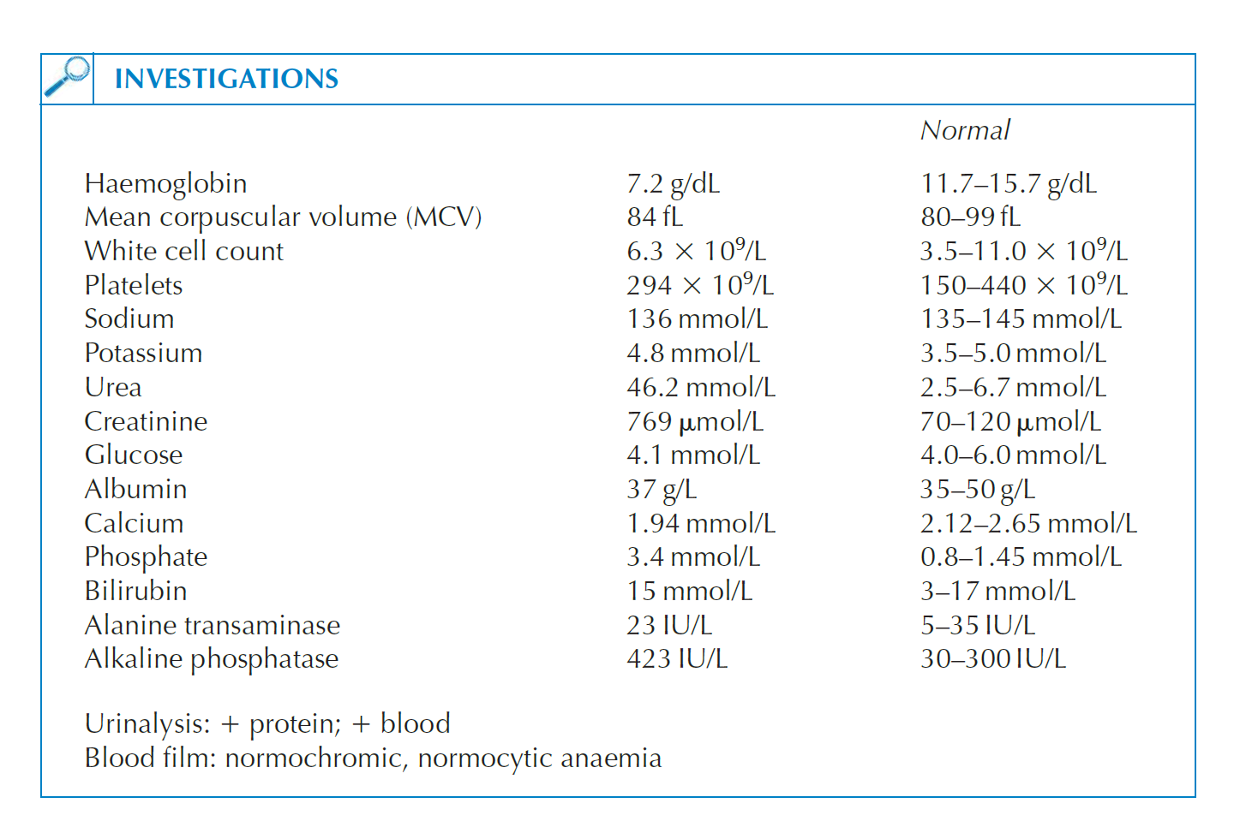
Blood film: normochromic, normocytic anaemia
Citation: Rees, P John, James Pattison, and Christopher Kosky. 100 Cases In Clinical Medicine, Third Edition. 3rd ed. Hoboken: CRC Press, 2013.

Renal6: Urinary Tract Infection

HISTORY
A 23-year-old healthy female college student, who has no children, presents to your office with a 2-day history of "on and off" dysuria, urgency, and frequency and a single episode of gross hematuria. There is no fever or back pain. She has self-medicated with cranberry juice and pyridium 200 mg, which was left over from a previous urinary tract infection (UTI). Her urine is consequently dark-colored. She has had 2 prior UTIs in the past year, which were successfully treated each time with trimethoprim-sulfamethoxazole (TMP-SMX) 160 mg/800 mg twice a day for 3 days. The last UTI was 4 months ago and there is no history of pyelonephritis.

She is heterosexual, has been sexually active since 18 years of age, currently uses an oral contraceptive, and has not missed any pills. She is currently in a monogamous sexual relationship. She believes that her partner is also monogamous. She has had a total of 1 lifetime sexual partner and does not admit to any history of sexually transmitted disease (STD). Her last menstrual period was 3 weeks ago, at the expected time.

PHYSICAL EXAMINATION

She is afebrile with no suprapubic tenderness or costovertebral angle tenderness.

Renal7: Hypertension with CKD

HISTORY

Mrs … 40 years old, housewife, nondiabetic, nonsmoker, hailing from …was hospitalized with
frequency of micturition, excessive thirst, weakness and palpitation ,anorexia, nausea and occasional vomiting for 2 months.

The patient was alright abou 2 years back. Then she noticed swelling of the face and legs,
associated with scanty micturition, increased thirst, palpitation and weakness for which she consulted with local doctor. After evaluation, she was diagnosed as a case of kidney disease and referred to nephrologist. She was hospitalized and thorough investigation was done including renal biopsy from left kidney. While she was in the hospital, treatment with prednisolone and ranitidine were given, continued for 6 months. With this treatment, the patient was feeling better.

About 2 years later, she again developed same type of illness. Her weakness is increasing, which is associated with severe loss of appetite followed by occasional vomiting. She denies any history of fever, abdominal pain, loin pain or burning during micturition. With this problem, she was admitted in the hospital. After evaluation, she was found having severe renal failure, hypertension, severe anemia.

PHYSICAL EXAMINATION
Ill looking, puffy face and depressed looking.Moderately anemic. Edema—present, pitting. Nail—half and half nail, no clubbing. No jaundice, cyanosis. No lymphadenopathy or thyromegaly. Pulse—110/min. BP—200/110 mm Hg. Skin—dry, there are multiple scratch mark.
Systemic examination

Gastrointestinal system
Lip, gum, tongue, oral cavity—looks pale.

Renal8: Urinary Tract Infection

HISTORY
43 year old woman with diabetes mellitus presents to the center complaining of chills, nausea and low back pain for the past 2 days. Earlier in the week she developed increased urinary frequency and dysuria. Recognizing the symptoms of UTI she took two
days of TMP/SMX but was unable to finish treatment because of nausea and vomiting Past medical history is notable for frequent UTIs treated with TMP/SMX and a history of Diabetes
Mellitus. No hx/o STDs, no vaginal discharge

